Budget Request for Family Care Providers
Governor’s proposal includes:
- Implement Fee Schedule ($44.5m AF)
- Continue ARPA increases ($81m GPR)
- Increase Direct Care Workforce Fund ($30m GPR)

- Significantly invest in the Family Care program with funds allocated directly to care and service providers.

- Uphold a minimum commitment to not cut provider rates: by requiring DHS to implement a hold harmless or minimum rate increase provision in the Family Care minimum fee schedule; and ensuring the ARPA-funded increases from last biennium continue.

Background

Wisconsin’s commitment to provide home and community-based long term care services to our vulnerable elders and individuals with disabilities is truly commendable. Those who deserve the most praise, however, are those caregiving providers that directly undertake this difficult work as part of their daily mission.

Expanding Family Care statewide has come at a cost for these caregivers who have been significantly underfunded and asked to “negotiate” reasonable rates with Managed Care Organizations (MCOs) who have been unable to deliver. Frequently, the only increases realized by providers have been those directly authorized or mandated by the Legislature and/or the Governor.

The Department of Health Services is currently working to create a minimum fee schedule so that provider reimbursements better approximate the true costs of providing quality care and services. The provider community generally supports such a fee schedule over “negotiating” with the MCOs, however, ultimate support will depend on whether the rates offered are reflective of actual costs.

The process to develop a fee schedule has not advanced to the point where providers can be assured of timely implementation that sufficiently meets their growing costs of providing care. Bridge funding (in the form of directed payments or additional direct care workforce funding) to get to the point of implementation is also critical.

Why are Family Care Provider Rates Needed?

- Long-term care providers are in a longstanding workforce crisis which is intensifying. The most recent provider survey of vacancies showed a doubling of caregiver vacancy rates from 2016 to 2022.
- Recruitment and retention challenges persist even though providers have increased starting wages for direct caregivers by an average of 22% from 2020 to 2022.

- Inflation is also hitting provider’s costs outside of caregiver wages. Hospitality supplies are seeing inflation at double the historical average. Food and energy prices are also increasing at unprecedented rates and MCO negotiated rates are not rising accordingly.
- While healthcare employment in other settings has rebounded from the pandemic, long-term care residential settings are still employing only 92% of their pre-pandemic FTE count.

- Wisconsin’s aging population will require additional long-term care services in the future. Family Care providers need to grow capacity to meet these care and service needs.

- If Family Care continues to reimburse far less than the costs of providing care, providers have no choice but to accept fewer Family Care residents or to cover costs through higher private pay rates, putting the price of assisted living unreasonably out of reach for the average Wisconsinite.

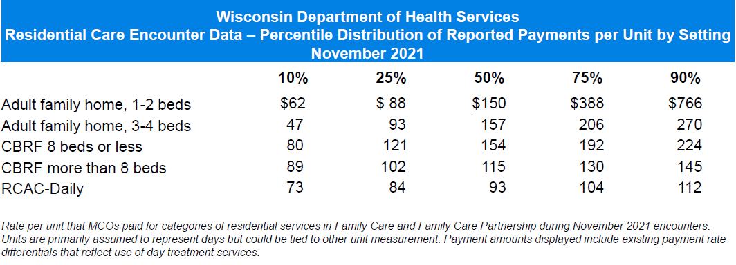
- Available DHS data (at right) indicates wide variation in MCO payment rates to providers. Although the proposed fee schedule would set only a minimum rate, following rate adjustments could result in dramatic disruptions to providers and residents. A hold harmless or minimum rate increase provision for providers already serving specific members is essential.
- Home and community-based long-term care services remain a bargain for Wisconsin taxpayers when compared to much higher costs of nursing home placement, keeping adult children out of the workforce to provide care, avoidable hospitalizations, or other adverse health outcomes for our vulnerable elders.
For more information, please contact:
LeadingAge Wisconsin:
John Sauer, President/CEO, (608) 444-9295 jsauer@leadingagewi.org
Rene Eastman, VP of Financial and Regulatory Services, (608) 400-5051 reastman@leadingagewi.org
Annette Cruz, VP of Public Policy and Advocacy, (608) 347-8190, acruz@hbstrategies.us

The Long-Term Care Workforce Crisis: A 2022 Report
The Long-Term Care Workforce Crisis: A 2022 Report
ValueFirst Commodity Report, 2023
BLS OES Data, March 2023

