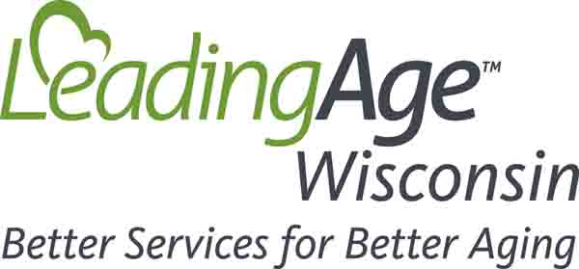

Legislative Meeting Discussion Prompts
- Be sincere and vulnerable about how the pandemic has affected you and your organization. Tell a story that will stick in their minds. Think about what you’ve told friends and family members about your pandemic experience as a long-term care provider.
- Support the story with information unique to your community/legislative district.
- LeadingAge Wisconsin will follow up with state/national data and proposed policy solutions in the future – no need to specifically address this in your meetings unless you want to.

Opening/Introductions:
- Describe the services you deliver.
- How long you have been around.
- Your impact on the community/legislative district (number of residents, number of employees).

Thank you:
- Budget increases were a lifeline to your organization, you couldn’t have done it without them.
- How hopeful did you feel when they passed and how has that changed over time?

Employees/Workforce:
- Describe the impact of the workforce crisis on your staff who are still showing up.
- How have your staff managed personally with outbreaks, childcare outages, and why do CNAs, RNs, dietary and housekeeping staff deserve better wages?
- Why is the LTC workforce crisis different than workforce issues other industries are facing?
- What is the number of open positions or FTE count now compared to pre-pandemic?
- What has the organization and its leaders done on their own to find solutions? (You are doing your best but need systemic payment reform and policy changes in the long term).

Residents/Care:
- Describe the impact of the pandemic and staffing shortages on your residents and their families.
- How has your census changed?
- How many referrals could you have accepted if you had more staffing or more resources?
- Are there particular residents you wish you could have admitted or that you know had a hard time finding services due to your organizations limited staff and resources?
- How have your acute care partnerships evolved and what do you wish for them in the future?
- Is your organization considering any structural changes to services and levels of care provided?

Closing:
- Let them know that LeadingAge Wisconsin will be following up with data and that you would appreciate their future support.
- Offer facility tours and invite to organization events or anything else you are willing to provide to educate and familiarize them with the long-term care provider community in their district.

