Link to the Direct Care Workforce Frequently Asked Questions Page:
https://www.dhs.wisconsin.gov/medicaid/ltc-workforce-funding-faq.htm
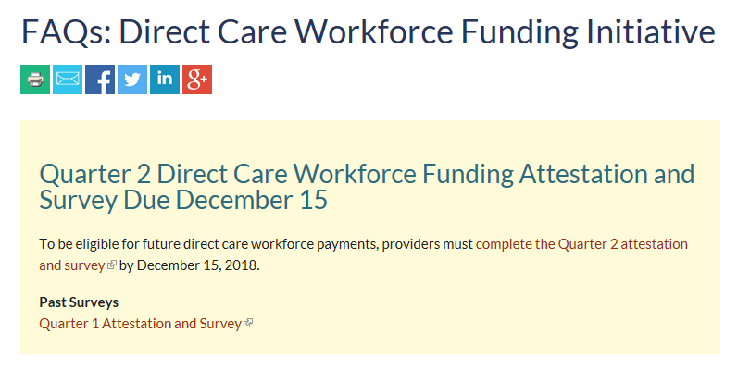
Click on the correct Quarter Attestation and Survey to complete the survey. A new survey will be posted on this page for each quarter. Providers will also be able to access all past surveys from this page.

SURVEY PAGE 1
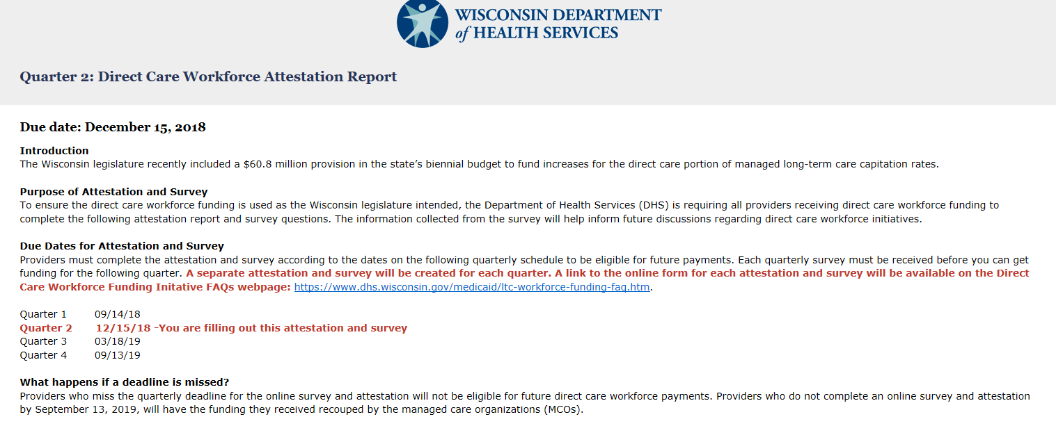
Click this link if you are not completing the Q2 attestation and survey.
Review due dates and what to do if the deadline is missed.

Survey Page 1, Continued
Read through background information and definitions as required before proceeding to the survey questions.

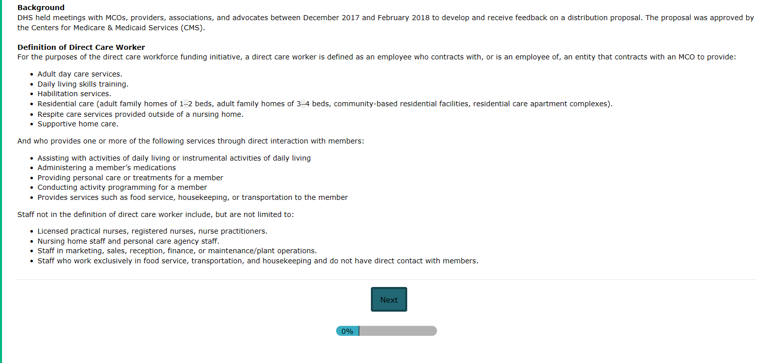

SURVEY PAGE 2
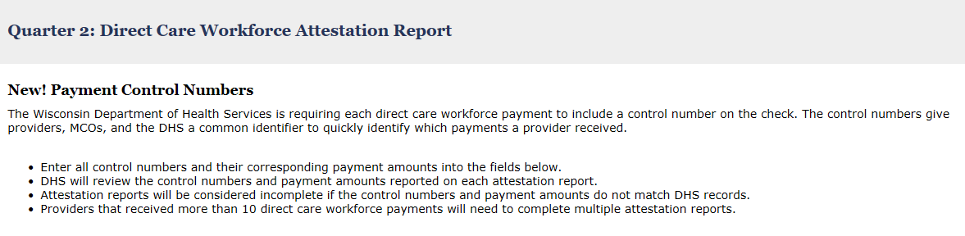
Review New! Payment Control Numbers instructions. Providers with more than 10 DCW payments will need to complete 2 or more surveys.

Survey Page 2, Continued

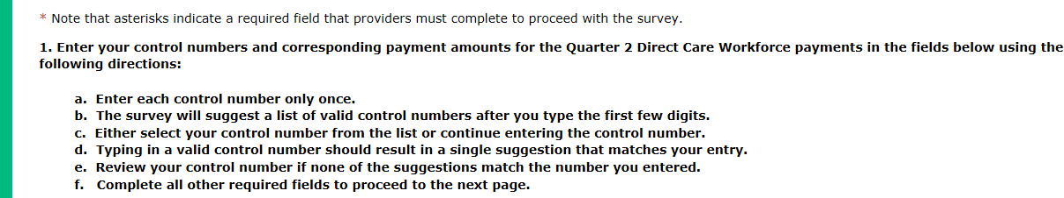
1a. Enter each control number once.
Follow Steps 1 a-f carefully. Note asterisks indicate a required field. The survey will only save valid control numbers.

Survey Page 2, Continued
1b. Enter the first few letters of the control number and wait. The survey will provide the list of valid control numbers to select from.
Continue entering the control number if the list does not pop up after a pause.
Tip: Copying and pasting even part of the control number into the survey helps the survey identify valid control numbers much more quickly. To speed up entering multiple entries, type your control numbers into a separate document and copy them to the survey.

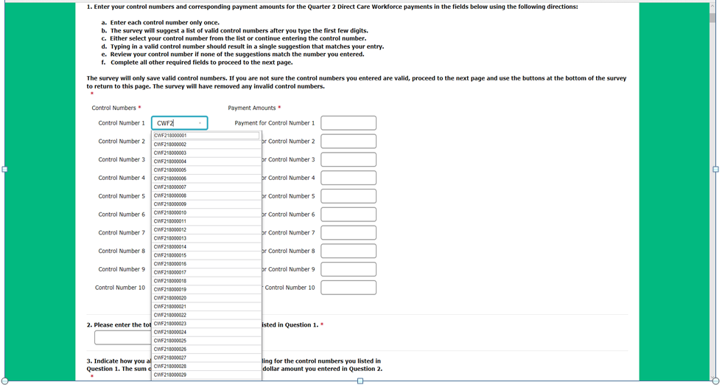
1c. Select your control number from the list or continue entering the control number.

Survey Page 2, Continued

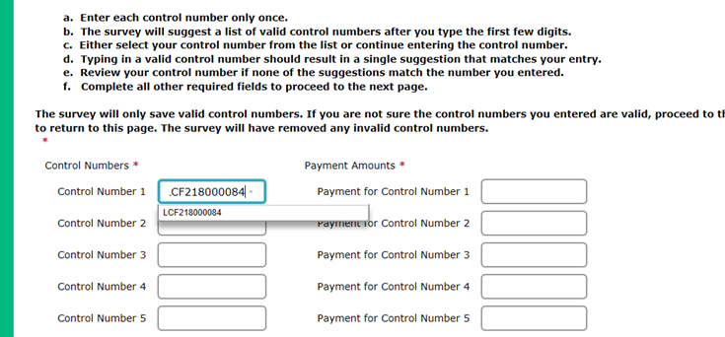
1d. Typing or pasting in a valid control number will result in a single suggestion that matches your entry.
1e. Re-enter your control number if you do not get a system match.

Survey Page 2, Continued

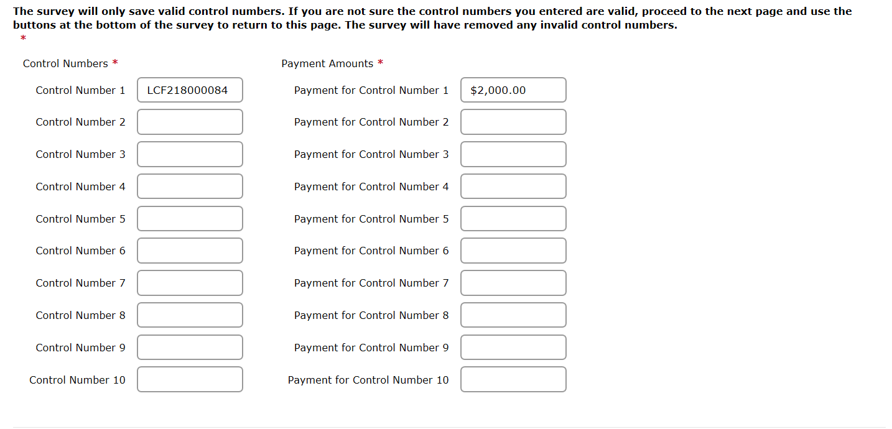
Enter the check payment that corresponds with the control number. Make sure the control number reference is the same for both the control number and the payment for the control number.

Survey Page 2, Continued
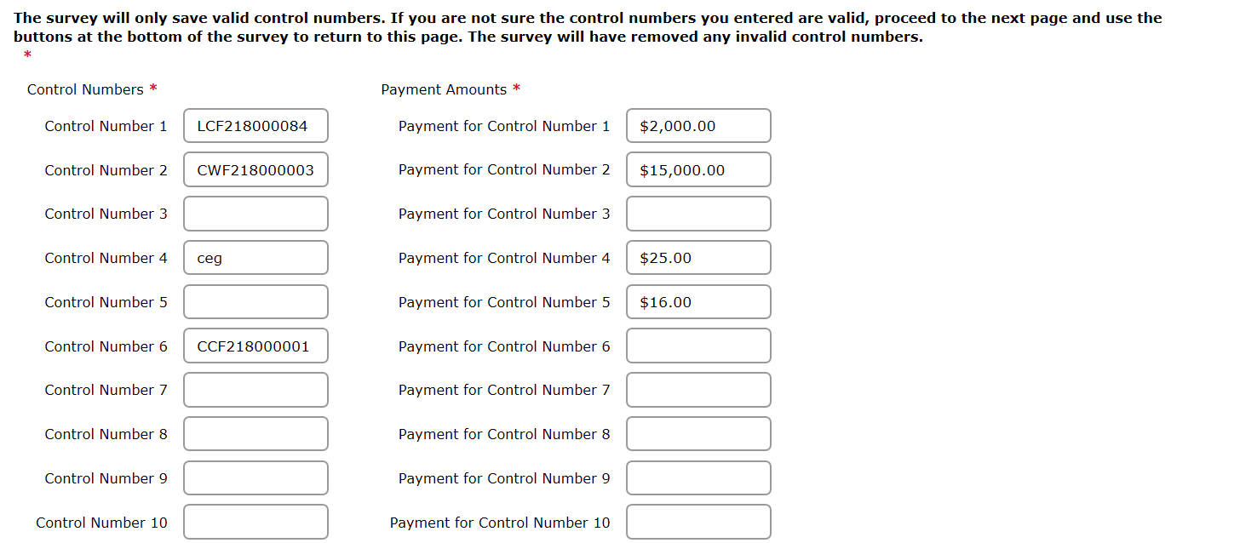
INVALID ENTRY
- Invalid control number “ceg”.
- Control number and payment amounts are entered on different lines.
- There are blank rows between entries.

VALID ENTRY
- Both control numbers are valid.
- Payment amounts are entered on the same line.
- There are no blank rows.

MAKE SURE THERE IS A ONE TO ONE ENTRY FOR EACH CONTROL NUMBER. PAYMENTS MUST HAVE VALID CONTROL NUMBERS AND CONTROL NUMBERS MUST HAVE VALID PAYMENTS.

Survey Page 2, Continued
ACCURATE SUBMISSION EXAMPLE
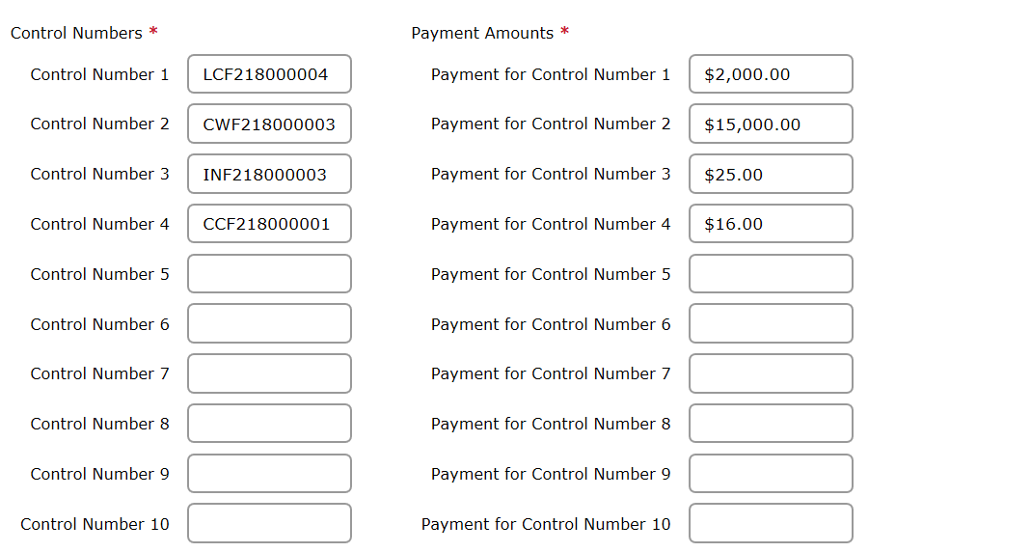
Complete an equal number of control number and payment field rows for the number of payments you received. Leave all others blank.
The survey has a limit of ten (10) entries for payments received. Providers that receive more than 10 payments should complete two (2) or more surveys in order to report all payments received.

Complete responses to Questions 2, 3 and 4 prior to advancing to the next page.

Survey Page 2, Continued
Attempting to advance to the next page without complete entry of Questions 1-4 will produce an error message. All errors must be corrected before the system will allow you to proceed.

The Survey tool cannot validate your answers in each to question to check that they agree. Please double check for consistency to avoid having your survey submission rejected. After you have double checked your responses, click on “Next” to go to page 3.

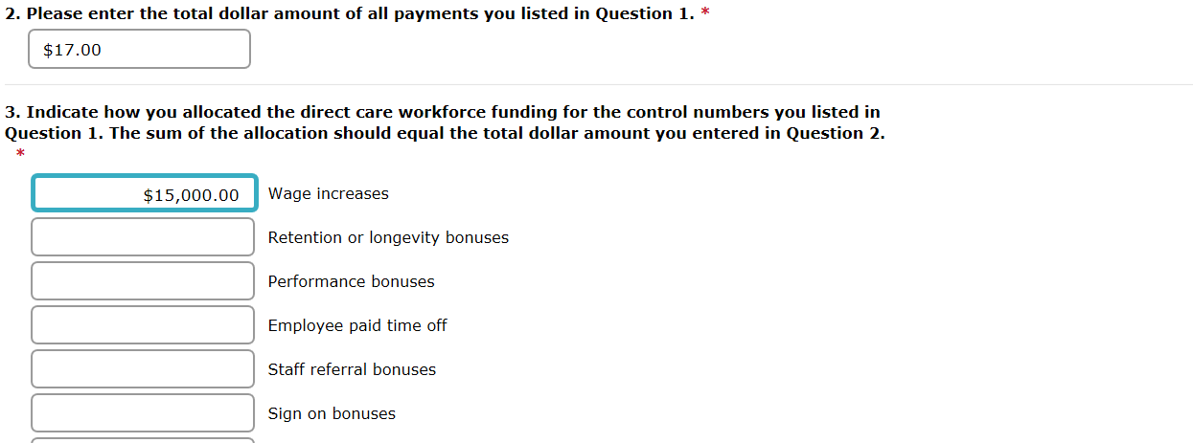
Total of all control numbers was $17,041.00. The entries in Question 2 and Question 3 should each be $17,041.00 and must be validated by you prior to submission to avoid survey rejection.

Survey Page 2, Continued
The survey will not save any invalid control numbers you enter in Question 1 on page 2. If you go to page 3 and then select “Back” to return to page 2, you can review your responses to Question 1 to make sure none of your entries were deleted. Re-enter any deleted control numbers and double check that the control numbers were entered correctly.

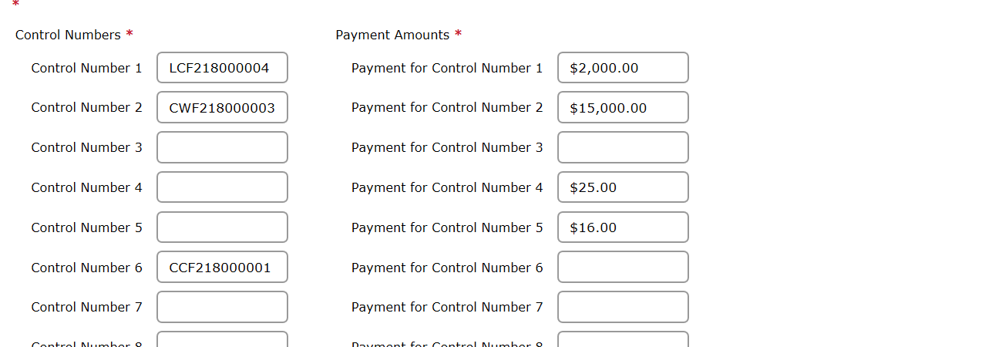
The survey deleted the control numbers entered in rows 3-5 because the control numbers were invalid. Leaving these fields blank would result in rejection of the survey submission.
Verify again that the total dollars entered in Questions 1-3 match one another. Surveys may be considered incomplete if these amounts are not consistent.

Survey Page 2, Continued
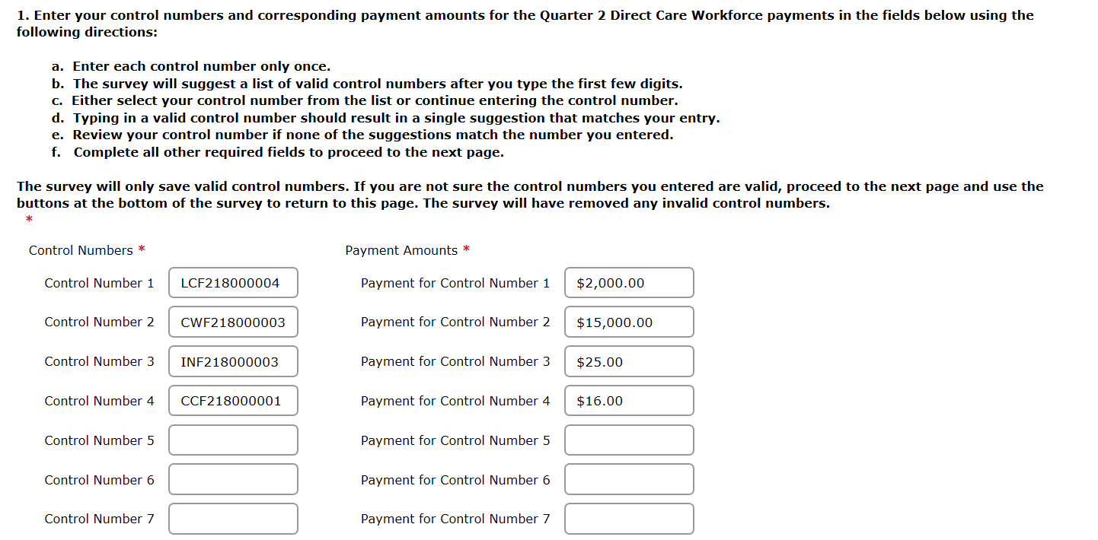
Totals in Questions 2 and 3 agree with the total of Question 1.

Total equals $17,041.00

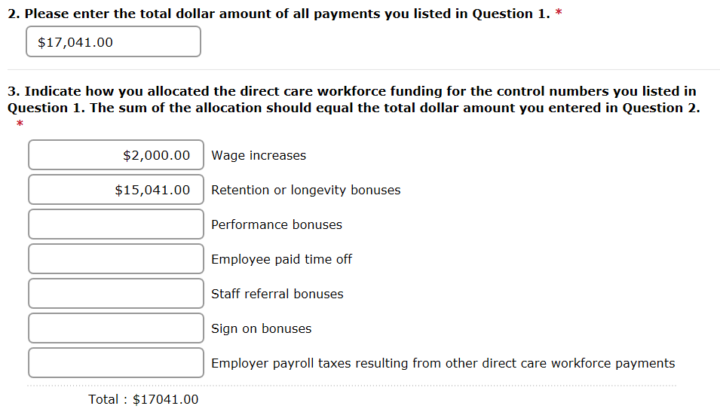

ONCE QUESTIONS 1-4 ARE RE-VERIFIED PROCEED TO QUESTION 5 ON THE NEXT PAGE

SURVEY PAGE 3
Questions 5 and 6 cannot be left blank. Entries must be completed in order to move forward to Question 7 in the survey.
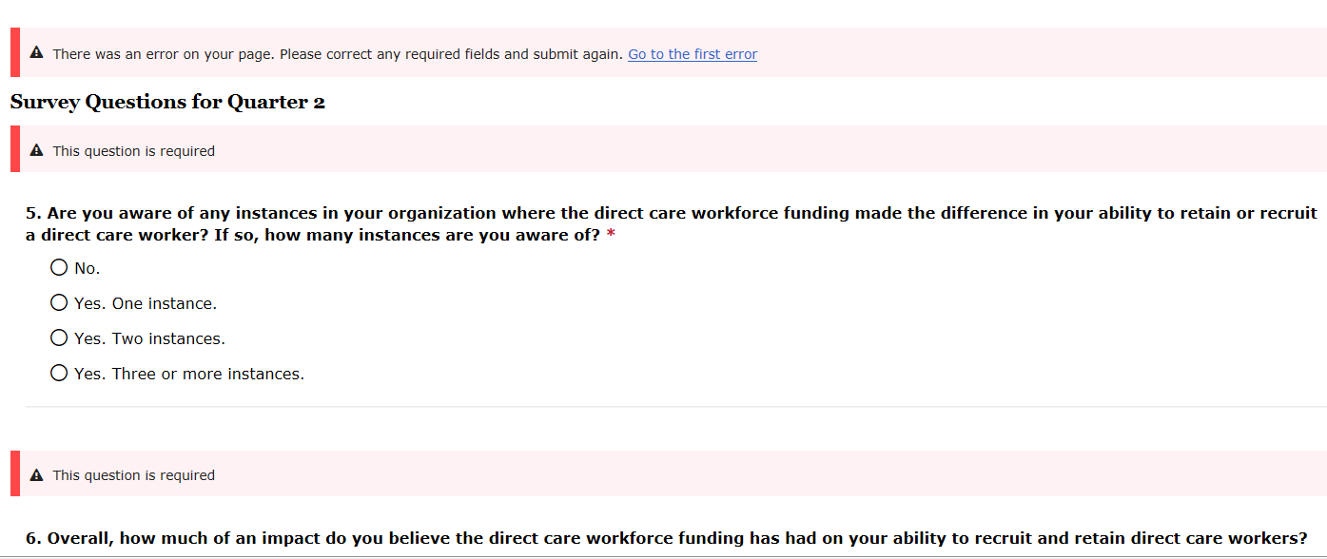

Survey Page 3, Continued
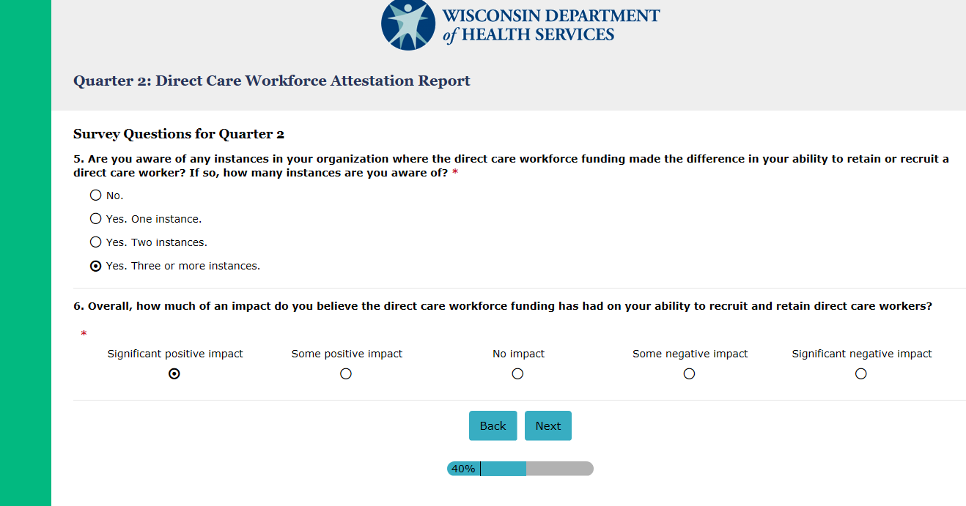
Once completed click Next at the bottom of the page to proceed.

SURVEY PAGE 4

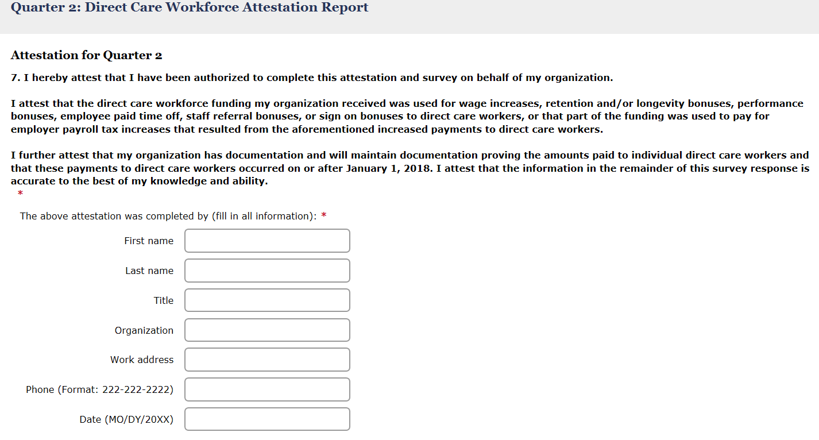
Read Question 7 carefully and fill out all fields to complete the attestation.

When all fields are complete select Next to submit your survey

Survey Page 4, Continued
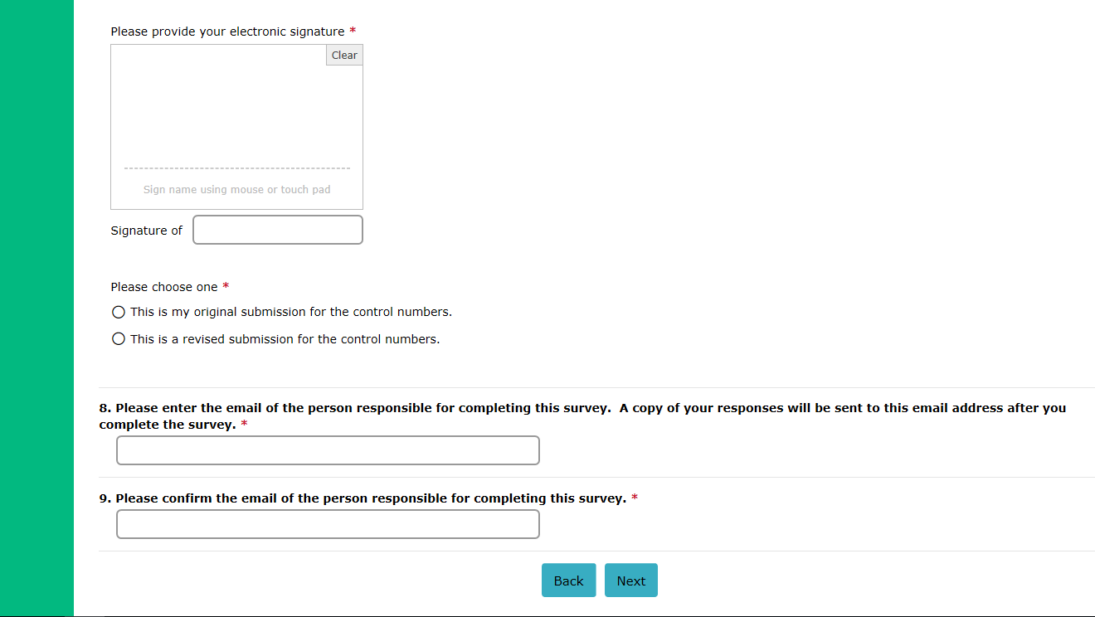
When all fields are complete select Next to submit your survey
Complete the electronic signature field.
Choose one to indicate whether this is your original submission or a revised/ corrected submission for the control numbers included on this survey.
Enter and confirm email address for the person responsible for completing the survey.

